Name: Diksha Singh

Course: Data Analytics Course

# EDA Report: Cryptocurrency Liquidity Prediction

1. **Introduction**

In this project, we analyse cryptocurrency data to predict liquidity, aiming to help understand market stability. Liquidity measures how easily an asset like Bitcoin or other cryptocurrencies can be bought or sold in the market without affecting its price.

# Data Summary

The dataset contains information about cryptocurrency prices, returns over 1 hour, 24 hours, and 7 days, 24-hour trading volume, market capitalization, and date.

Below is the summary of the dataset:

|  |  |  |  |  |  |  |  |  |  |  |  |
| --- | --- | --- | --- | --- | --- | --- | --- | --- | --- | --- | --- |
|  | price | 1h | 24h | 7d | 24h_ volu me | mkt_ cap | date | price  _ma_ 2 | mkt_c ap_m a_2 | vol atili ty | liquidi ty_rati o |
| c o u nt | 992 | 992 | 992 | 992 | 992 | 992 | 992 | 991 | 991 | 992 | 992 |
| m e a n | 620.0  5212  75 | 0.009  6824  6 | 0.024  0181  45 | 0.023  5584  68 | 2884  6384  5.6 | 3783  9507  96 | 58:32.  9 | 600.0  6203  91 | 33987  38445 | 0.0  286 | 0.102  41504  1 |

|  |  |  |  |  |  |  |  |  |  |  |  |
| --- | --- | --- | --- | --- | --- | --- | --- | --- | --- | --- | --- |
| m in | 1.48  E-09 | -0.70  4 | -0.64  6 | -0.55  8 | 0 | 6577  0433 | 3/16/2  022  0:00 | 0.000  3076  94 | 66055  442 | 0 | 0 |
| 2  5  % | 0.194  0547  5 | 0.001 | 0.001 | -0.04  1 | 1764  198.2  5 | 1158  5006  7.3 | 3/16/2  022  0:00 | 0.676  7785  78 | 11720  1450.  5 | 0.0  06 | 0.008  75873  8 |
| 5  0  % | 1.095 | 0.006 | 0.016 | -0.00  05 | 8328  741 | 2131  9527  1 | 3/16/2  022  0:00 | 2.383  175 | 21430  7314 | 0.0  15 | 0.033  73807  3 |
| 7  5  % | 6.955 | 0.019 | 0.035 | 0.037 | 3947  2221 | 5972  4931  1.3 | 3/17/2  022  0:00 | 19.45  0084  25 | 60988  2897.  3 | 0.0  33 | 0.087  05295  8 |
| m a x | 4121  7.27 | 0.095 | 0.577 | 4.608 | 5793  4969  077 | 7.760  77E+  11 | 3/17/2  022  0:00 | 2183  7.9 | 5.575  77E+1  1 | 0.5  3 | 5.948  54485  8 |
| st d | 4421.  9979  63 | 0.026  9174  65 | 0.058  6678  35 | 0.229  7812  64 | 2771  1763  34 | 3818  9701  989 |  | 3044.  1173  64 | 27444  32970  5 | 0.0  461  91 | 0.364  72187  1 |

# Visual Explorations Bitcoin Price Over Time:

The trend of Bitcoin's price was plotted over the two days.

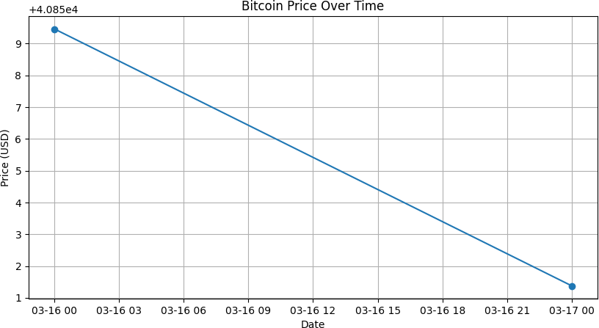

# Correlation Between Numeric Features:

The correlation heatmap shows how different numerical features relate to each other.

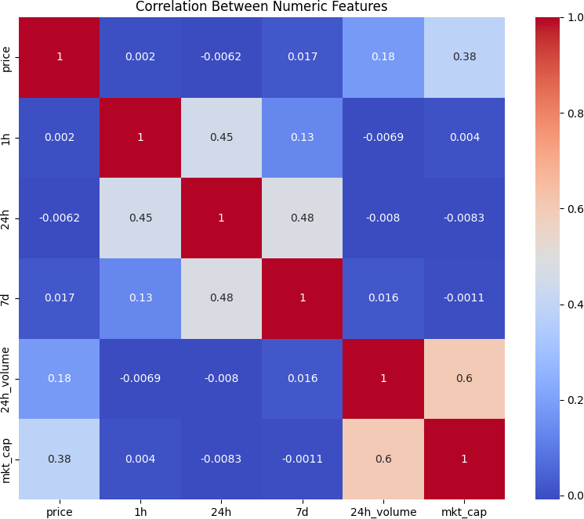

# Key Observations

* + Bitcoin's price remained mostly stable across the two-day period.
  + There is a strong positive correlation between cryptocurrency price and market capitalization.
  + Volatility has a minor correlation with liquidity ratio.
  + Trading volume also shows moderate relationships with liquidity.

# Conclusion

Exploratory data analysis helped in understanding key relationships in the data.

This exploration guided the creation of new features like volatility and moving averages, leading to the development of an accurate machine learning model for liquidity prediction.